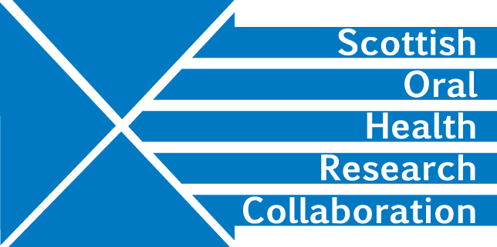

SOHRC: Craniofacial Research Group meeting, Tuesday 4th September 2018, 3.15-5.15pm at the Edinburgh Dental Institute, DDMR room, 4th floor
Minutes
Apologies: Grant McIntyre, Angus Walls, Weihua Meng, Aileen Bell, Toby Gilchrist
Present: Peter Mossey, Ashraf Ayoub, Mairead Bermingham, Xiangyang Ju, Felicity Mehendale, Deirdre Kelliher – FM asked for an additional member to be added to the mailing list. DK will follow up - Action DK
- Minutes of last meeting
No comments were made.
- Update on NIH application
The NIH application has been resubmitted but to a more appropriate committee this time. A decision on funding is expected by the end of September.
The meeting considered other options for the project should the current application not go through to the next stage in the award process. The Group should:
Investigate other funding opportunities for the whole or parts of the application – Action All
Invite Peter Claes to Scotland for discussion in Jan 2019 – Action PM/AA
Invite Peter Hunt - Action PM/MB
- Bodore Albaker Craniofacial project
Bodore is a former Edinburgh student who is now a candidate for PhD study across the Craniofacial research group instiutions.
PM will circulate the date of her arrival. - Action PM
The group needs to set the framework for her project. It should have clear aims, a timetable, milestones and a protocol. - Action All
- Update on Zika virus project
YJ has been carrying out analysis of the data. AA has approached Raju Sangra (Craniofacial expert) at the Glasgow Children’s hospital for assistance in categorising the data which could enable Health authorities to define treatment. A new method for measuring microcephaly could come out of this work.
FM stressed the advantages of longitudinal follow up. This should involve local experts who may already have collected data. She will investigate funding to cover the cost of a visit to Scotland by the Neuroscientist, Adriana (Surname?). - Action FM
AA plans to invite Leonardo Freitas to visit again for further analysis. – Action AA
MB had already circulated some questions to the group for consideration. She will now also send them to FM.
MB suggested involving James Bordman and Alan Quigley. She will send them the XJ’s paper. She will inform them that there is currently an embargo on the data. - Action MB
The Group needs to examine funding opportunities for the Zyka virus project - Action All
- SOHRC spring event - student thesis 3 minute presentations
The SOHRC Craniofacial Group should have 8 or 9 students:
Glasgow – 3
Dundee – 5
NHS Glasgow – possibly 1
- SOHRC website – group representative
DK is currently working on updating the website and will let the group now when this is available to view. AA has sent DK material for the Craniofacial Group.
A poster abstract is being submitted for the NHS Research Conference in October.
DK has produced a slide presentation on SOHRC and will forward this to the group for comment.
- Action DK
- Felicity Mehendale research plans and ICC 2021
FM is organising ICC 2021 in the UK and a venue has already been booked. She is setting up a task force to plan and manage the event – Jeff Marsh is co-chair. The sponsorship brochure is now in draft format. Consideration is being given to simultaneous translation and languages may include French, Spanish and Chinese.
- AOCB
It was noted that the Scottish Government had awarded a grant to the University of Glasgow in collaboration with the University of Malawi, Malawian Government organisations and the University of Dundee for the MalDent project. The University of Glasgow will administer the award, which is due to start in autumn 2018.
AA reported on his work with KLS Martin to validate the company software. AA and YJ have both visited the company and a research proposal has been submitted.
- Date and Venue for next meeting
Dundee – 28th Nov 3.15-5.15.

