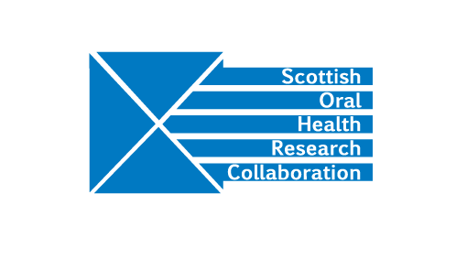
Minutes of the SOHRC Board Meeting, Monday 29th April, 2.00-4.00pm at St Andrew’s House
Present: Tom Ferris, Rasha Abu-Eid, Angus Walls, Jeremy Bagg, David Felix, Lorna Macpherson, Peter Mossey, George Cherukara, Jan Clarkson (by teleconference), Nicole Alterado, Deirdre Kelliher.
- Welcome and introduction – Tom Ferris welcomed the SOHRC Board to the meeting. Apologies were received from Mark Hector and John Gibson. R A-E attended to represent the University of Aberdeen.

- Minutes of the previous meeting – one amendment was requested. Ben Lamb should be amended to Benoit Varenne. Action DK

- Public Health and Health Services Research Group
LM presented two briefing papers: “Improving systems of care for the older person (ISCOPE)” and “Fluoride application: a co-designed toolkit of organisational strategies” to demonstrate the current work of the group. The Group is negotiating with a software company about extending and developing ISCOPE. TF will consult with Scottish Government colleagues to assess interest in the ISCOPE work. Action TF

The group plans to submit an application for a CSO catalyst grant to fund the next stage of the Fluoride varnish project. LM raised the issue concerning discussions which had been held with Margie Taylor and TF concerning the ongoing evaluation of Childsmile and the intention for a commissioned call via CSO. TF is in discussions on the matter and will let the Board know when a resolution has been reached. Action TF

JC reported that £2.4 Million has been awarded by NIHR for the project, “Partial removal of dentinal caries in permanent teeth”. The contract with NIHR is due to be signed in June. The project is led by Dundee but also involves Aberdeen and Glasgow.
A further outline application has been submitted to NIHR, “Pulpotomy for the management of irreversible pulpitis” which is a collaborative project among Dundee, Glasgow, Aberdeen and Edinburgh.

- Craniofacial Research Group
PM presented a briefing paper on the work of the Craniofacial research group.

Zika virus project – the work involves a collaboration between the group and Adrianna Mattos from Salvador, Brazil. The research has led to a new method of measurement for microcephaly. A paper presenting the findings of the group will be submitted to the Lancet. The work will also be of value to a range of craniofacial conditions.

PhD student, Bodore Albaker has begun working on the craniofacial genotype-phenotype correlation project using Generation Scotland data. Glasgow, Dundee and Edinburgh are all involved. There are now 5 craniofacial PhD students at Glasgow and 4 at Dundee and a network has been established to allow interaction of the students to discuss their project work.

The group will be closely involved in the 2021 International Craniofacial Congress, hosted by the President and Group member, Felicity Mehendale.

Future developments for the group include a possible collaboration with forensic scientists and psychologists on forensic reconstruction, facial identification and security.

TF asked the Group to consider whether it would be useful to raise awareness of their work with the Scottish Health Minister, Joe FitzPatrick. PM will follow up with Group members. Action PM

- Education Research Group
GC is taking on the role of Research Lead for the Education Research Group.

- Meeting of MMI leads – the MMI subgroup last met in March and during that meeting concentrated on selection processes in relation to Dental Therapy students. Work is at an early stage and GDPR issues still need to be resolved. GC should contact Jamie Dickie at Glasgow for advice. Action GC
DF suggested that it could be useful to set up a GDPR Group involving GDPR officers from each institution within SOHRC. Action all

- Administrator’s report
DK provided a paper detailing SOHRC Research Groups meetings since the last Board meeting in October and planned events for 2019.

- REF 2021
No decision has yet been taken with regard to a joint submission between Glasgow and Dundee.

- SOHRC conference/3 Minute theses presentation competition – 1st October
JC will give the keynote lecture. SOHRC PhD students will present their research in 3 minutes to demonstrate the breadth of SOHRC research. There will not be a competition on this occasion. DK will contact the research groups for names of students who will participate. Action DK

- AOCB
The Oral and Dental Health leads (David Conway and JC) are working with Alan McNair at CSO and the R&D offices in Glasgow and Dundee to establish a framework for dentistry funding via CSO.

PM made enquires in relation to widening the University of Dundee WHO Collaborating Centre status to include all SOHRC institutions. WHO has begun a process of restructuring within Oral Health and no changes can currently be considered.

- Date of next meeting
DK will seek possible dates from NA and setup a Doodle poll. Action DK

