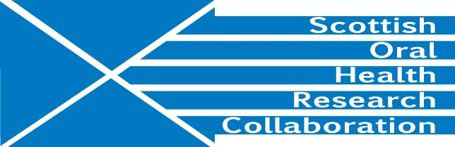

Minutes of the Public Health and Health Services Research Group Meeting, Dental School Administration Centre, Level 5, Glasgow Dental Hospital and School, Thursday 27th June, 10.45-12.45 pm
Present: Jeremy Bagg, Lorna MacPherson, Linda Young, Ruth Freeman, Jan Clarkson (via phone link), Al Ross, Deirdre Kelliher
- Welcome
JB welcome members of the Group to the meeting.

- The minutes of meeting held on 10th December were found to be correct.

- Improving Systems of Care for the Older Person (ISCOPE) – AR briefed the group on the work of the project and its findings. He is now engaging with a software provider to develop an intervention and plans to hold a workshop to facilitate feedback. He will also focus on a report and papers for publication. There is a joint paper with Prof Belinda Brewer and her team at UWS. Further work with UWS is possible in the future. JC recommended discussion with Nicola Gray. She will contact Nicola, copying AR into the message. Action JC
FACTORS – Fluoride application: a co-designed toolkit of organisational strategies
The toolkit was designed in conjunction with GDPs and developed with APS (Scotland) Group. An application to test the feasibility of the toolkit will shortly be submitted to CSO for a catalytic grant. (up to £35K)

- NIHR projects
The contract between NIHR and Dundee for the SCRIPT award has now been signed. The trial commenced on 1st June and the first collaborators meeting will be held on 10th July. An advert has been placed for a clinical researcher.

The most recent NIHR HTA application, Pulpotomy for the Management of Irreversible Pulpitis, has got through the outline stage and will now become a full application with a deadline of 26th July.

- Child oral health
LM is in discussion with Tom Ferris about the continuation of the Childsmile evaluation programme. The CDO office is commissioning external evaluation of all projects. However, the EU has already evaluated Childsmile favourably. LM will send the details to TF. Action LM

- Other research projects
RF runs two national Health Coaching programmes – one on homelessness and one for young people. An application to CSO is planned with DC and AS on health coaching in prisons. She is also involved in a Challenge Fund project with the Scottish Drug Forum.

LY reported that the fissure sealant project had not received funding and no feedback had been provided.

DC is part of a large consortium working on the EU funded Headspace project looking at head and neck cancer in Europe and South America. A PhD student has been appointed to commence in October.

- SOHRC autumn conference
JC will present the keynote lecture and will provide DK with a title for the conference programme by mid-July when the conference booking will be opened. Action JC
DK will arrange to visit Dundee to view the Dundee Dental Education Centre premises
Action DK
PhD students will present for 3 minutes under any of the three SOHRC research themes. All students with relevant projects should be encouraged to take part. Action All
- SOHRC website
DK has updated the SOHRC website this year but needs more material to keep the news section fresh. Articles or information for the website should be sent to DK.
Action All
- AOB
Glasgow and Dundee will make individual REF submissions. However both institutions will mention the importance of joint working through SOHRC in the Environment section.

- Date of next meeting
Early October after the SOHRC conference. DK will set up a Doodle poll. Action DK

