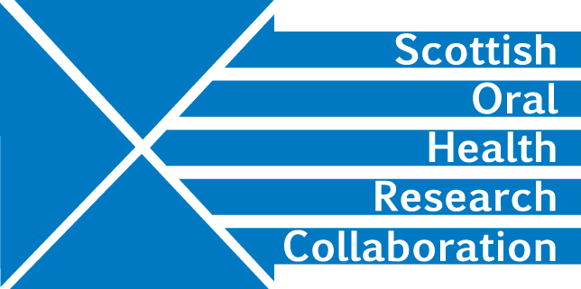

Minutes of the Public Health and Health Services Research Group Teleconference meeting on Thursday 7th November 12.30-1.30 pm
Present: Lorna MacPherson, Andrea Sherriff, Ekta Gupta, Jan Clarkson, Linda Young, Ruth Freeman, Deirdre Kelliher
Apologies: David Conway, Al Ross, Jeremy Bagg

- LM chaired the meeting.

- The minutes of meeting held on 27th June were confirmed as correct.

- JC updated the group with progress on Dundee projects under the Child Oral Health theme. The first meeting of coapplicants relating to the project, “Can Co-Design Enhance National Quality Improvement Interventions?” has taken place. The ethics application is in progress and research will commence on 1st March and run for 6 months. The project which involves the Universities of Dundee, Glasgow and Aberdeen will run a series of co-design workshops with Dental practitioners in Dundee and Aberdeen and then will follow up with a further workshop for user testing. LY requested group members to let her know if they were aware of any suitable candidates for the research assistant position. Action all

LM reported that Al Ross’ CSO project, “FACTORS- (Fluoride Application: a Co-designed Toolkit of ORganisational Strategies)”, will commence on 1st Jan. The plan is to test the feasibility of a toolkit for fluoride application. The toolkit was co-designed with practitioners and a software company.

Since both CSO projects complement each other, the two teams will get together at the end of the project to look at the findings in relation to prevention and practice for children. This fits well with the Scottish Government oral health strategy. Dk will set up a Doodle poll to arrange a suitable meeting date in October. Action DK

- JC reported that the SCRIPT Trial Team was moving ahead with the project. Ethical approval is currently being sought in Aberdeen and recruitment is expected to begin in early 2020 with the aim of engaging 650 participants in 5-6 practices. The second NIHR project, “Pulpotomy for the Management of Irreversible Pulpitis”, has been awarded and is currently in the negotiation phase so a contract has not yet been issued. Chris Deary is the paediatric lead.

- RF reported that her project on oral health in prisons had not been funded by CSO. She would like to submit a related application to the NIHR call on interventions for people under community orders for the March 2020 deadline. RF will send a copy of the unsuccessful application together with feedback from CSO to the Group for comment and discussion at the next SOHRC Public Health and Health Services research group meeting. Action RF

EG’s ODRT funded grant on oral health for older adults with chronic disease is currently going through ethical approval at Aberdeen. She hopes to commence work in February.

AS reported that the Dunhill I-SCOPE project has finished. Reports have been sent to Dunhill and the team is now working on submitting papers for publication.

- Feedback from the SOHRC conference evaluation forms was mainly positive. DK will send out the summary of evaluation forms to group members. Action DK

- The SOHRC website will be updated to include details of the conference. JC will arrange for recordings of her presentation and the one made by Doug Stirling to be sent to DK for uploading to the SOHRC website. Action JC

The content of the SOHRC Public Health and Health Services pages need to be reviewed and updated. More relevant pictorial images are required. DK will send a
copy of these pages to the group for comment and revision. Kelly Urquhart should be included in the circulation. Action DK

DK should seek a summary of the SCRIPT Trial from Ruth Floate. It may be possible to include a link to the trial website. Action DK

- The next meeting should take place in January. DK will set up a Doodle poll.
Action DK

