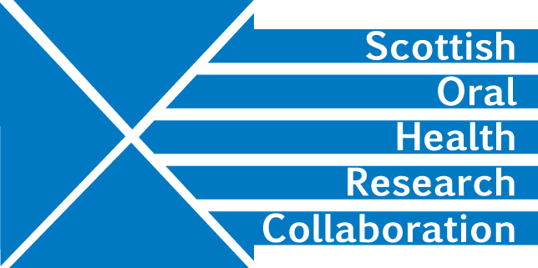

Minutes of the SOHRC Dental Education Research Group Zoom Meeting of MMI Leads (Dental Schools only) on Wednesday 26th August 10.00am-12.00 pm
Present: Malcolm Stewart, Viv Binnie, Fiona Stewart, Deirdre Kelliher
- Research Proposal – Current MMI’s themes and attributes measured
- Next steps
The Group formulated a research question at its last meeting but progress has been delayed by the current pandemic. VB confirmed that Jamie Dickie is interested in linking with the SOHRC Education Group MMI project. VB will invite him to the next meeting. Action VB

VB raised the issue of governance in relation to virtual data collection. It was noted that George Cherukara’s Governance Group is looking at these issues. VB will discuss with George Cherukara. Action VB

- This years MMIs -Plans- virtual vs face to face
Aberdeen is planning to continue with its MMIs in December. “Collaborate” was the on-line system used for international students last year and may be used again since face to face MMIs are unlikely to be possible given that room capacity is now strictly regulated.

Glasgow holds its MMIs in January and this will probably be online too.

Dundee used TEAMS for their international students last year and noted that those interviewed on-line performed better possibly because they had the opportunity to prepare in advance. However, it is difficult to compare face to face with online MMIs. FS is interested in including a station to measure responsibility. This has not yet been included in MMIs at Dundee.

It’s important for all Schools to consider which stations to include in relation to the attributes they want to measure as online MMIs may need to be shorter. MS will contact Christine Goodall to discuss further. Action MS

Given the all the issues Dental Schools are facing, the Group felt that it was unlikely that members would have the time to write a research proposal before the end of the year. However, this group is still useful for sharing information and experiences including lessons learnt from the change in approach to MMIs.
AOCB
MS will contact the Therapy Schools members to see if they would like to hold a separate meeting once they have decided on their approach to MMIs for the forthcoming year. Action MS

- Date of next meeting
November 2020. DK will contact MS for a suitable date. It would be useful if a date could be found which would enable Christine Goodall to attend. Action DK

