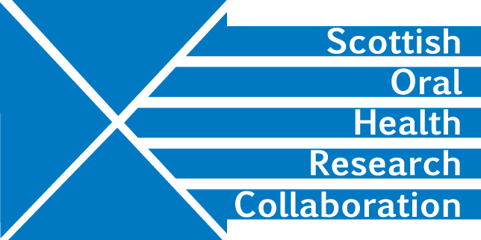

Minutes of the SOHRC: Craniofacial Research Group: Research leads Zoom meeting, 2.00-4.00pm, Wednesday 27th May
Present: Peter Mossey, Ashraf Ayoub, Felicity Mehendale, Xianyang Ju, Angus Walls, Deirdre Kelliher
- Ongoing SOHRC Craniofacial Research projects
The main projects here are Bodore Albaker’s studentship and the Zika virus collaboration.

- Future planning relating to synergies in expertise and resources
SOHRC has a wealth of expertise in the Craniofacial Research Group with access to the Generation Scotland and other data and excellent analytical tools. XJ is an image analyst. The group needs to concentrate on developing proposals for future projects which could bring in external funding to further collaborative research.

- Collaborations on 3D imaging, 4D (animation), AI, machine learning and ALR
Both Glasgow and Dundee have 3-D imaging systems while Edinburgh is process on acquiring one though FM already has access to this facility through Paediatrics.
Existing or developing links include:
Mathematicians at Dundee
Informaticians at Edinburgh
NHS
University of Pittsburgh

Questions to be answered:
What additional expertise is required to establish excellent collaborations?
Is the expertise in demand?
Is the research translatable?
What should the focus of this group be?
What can SOHRC contribute?

Possible funders: could be
Smile Train though this would be research using Smile Train data.
FM will put a document together and send to AA and PM for comment and amendment. Action FM
PM will approach Priya Desai Action PM
CSO
Research Councils
NIHR HTA

- Ensuring continuing educational element
The potential Smile Train work could bring further opportunities for collaborative studentships.

- International Cleft Congress 2022 and SOHRC
This takes place in Edinburgh. The group needs to think about the SOHRC role.
Action ALL

- Next update for SOHRC Steering Committee?
There will be no Steering Committee meetings in 2020.

- AOCB

