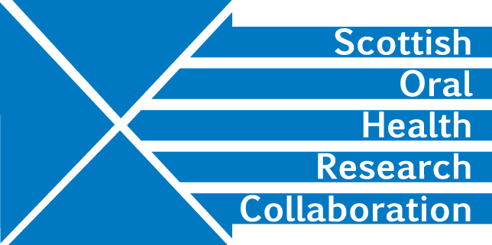

Minutes of the SOHRC: Craniofacial Research Group: Research leads
Zoom meeting, 4.00-5.00pm, Tuesday 21st July
Present: Peter Mossey, Felicity Mehendale, Ashraf Ayoub, Xiangyang Ju, Deirdre Kelliher
- SPARKS funding opportunity (collaboration)
AA asked all Group members to log into the GOSH/SPARKS application system to see the latest version of the application and accept co-applicant participation. Action All

The application needs to address the rare disease issue to convince the funder that the project is eligible for funding. PM has circulated the paper which he presented to the EC to gain acceptance of Cleft Lip and Palate as a rare disease. This argument should be incorporated into the current proposal. However, to avoid early rejection FM will speak to the funder prior to the submission deadline. Action FM

The proposal needs to be clear on what the project will deliver. It also needs to demonstrate the benefits the research will bring to clinicians and show how the current group of applicants are the ideal candidates to lead this research. Value for money will also be important.

The project needs a full-time computer scientist to develop an app and software package using the expertise among the applicants in 3D and 4D imaging. Patients could take their own smart phone images thus avoiding the need for as many clinic visits during the pandemic. The images could be remotely uploaded for analysis by clinicians. Speech therapists might also be prepared to share their videos. FM will discuss this with colleagues and report back. Action FM

PM will modify the language in the current application to present a convincing argument. Action PM

FM will look at objective outcome measures. Action FM

AA and XJ will work on the proposal revision. Action AA and XJ

DK will work on the costing and send a draft in the next couple of days. The project requires a Computer scientist, a high power computer. Dissemination costs and a server.
Action DK

- Other opportunties
The Group should look at the CSO/Liffearc translational opportunity – is there any mileage here? The deadline is the end of July. Action All

- Smiletrain
FM and PM will discuss in a separate meeting and report back. Action PM and FM

- Zika virus
AA is continuing work on the zika virus research. It could be beneficial to hold discussions with James Boardman in Edinburgh to see if comparisons can be made between the MRI data he holds with the data obtained in Brazil. FM will approach him by email and copy AA in.
Action FM

- AOCB
FM requested that her Edinburgh University email address - Felicity.Mehendale@ed.ac.uk should be used for all correspondence.

- Next meeting
The next meeting should take place in 2 weeks. DK will arrange and send out a Zoom invitation. Action DK

